BUDAPEST ideal, inspiring break
5 Days 4 Nights
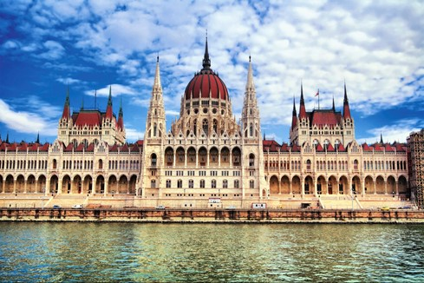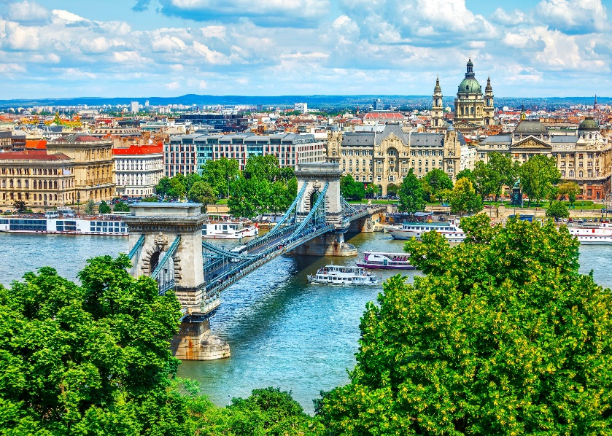
Budapest and its colorful Palaces, playful Blue Danube and Museums exude the opulence of an inspirational Capital. Discover Habsburg splendors, Ottoman architecture and relaxing Spas, make Budapest an ideal and inspiring place for a luxurious break.

Y2024 PROMOTION + 10% Discounts. LOW BUDGET PACKAGES.
BOOK NOW. LIMITED AVAILABILITY.

Package is quoted per person in Euro and includes:
- 04 nights at HAND-PICKED* Hotels of your Choice
- Bed & Breakfast basis
- Round trip transfer: Airport / Hotel / Airport by private transfers
- Travel insurance including Covid
- Validity: till May 2024
- Package excludes Airline Ticket

Star | Hotel name | Room Type | Price
4 | Soho Boutique Hotel | Double | € 239
3 | The Three Corners Lifestyle Hotel | Deluxe | € 268
4 | Buda Castle Hotel Budapest | Superior | € 280
3 | Three Corners Hotel Art | Deluxe | € 285
3+ | D8 Hotel | Standard | € 288
4 | Ambra | Standard | € 297
4 | Continental Hotel | Standard | € 314
4 | Ikonik Parlament | Deluxe | € 317
5 | Prestige Hotel Budapest | Standard | € 343
3 | The Three Corners Downtown Edition | Premium | € 372
4 | Hotel Moments Budapest | Superior | € 389
4 | Zenit Budapest Palace | Standard | € 389
4 | Barcelo Budapest | Superior | € 449
4 | Hotel Moments Budapest | Room Run of House | € 510
5 | Corinthia Budapest | Superior | € 637
5 | Hotel Clark Budapest - Adults Only | Courtyard - Inner Peace | € 650
Important Notices:
- * Hand-Picked Hotels: All hotels are located in the very heart of the city, with worldwide good ranking & reviews. We are doing our best endeavors to continuously add new hotel options.
- Promotional Prices are subject to change or termination at any time.
- Terms and Conditions apply (e.g. blackout periods, other).
- The above hotel list is Not exhaustive. Other hand-picked hotel options are available.
- Room types or category may be different and subject to availability.
- Prices are subject to change according to Availability at the Date and Time of booking.
- In case the mentioned hotel is unavailable, then alternate hotel of similar category will be provided.
- Packages can be tailor-made. Just email us.
KNOW BEFORE YOU GO: WHAT TO SEE & DO

For more details on Budapest Sites and Country Facts, click on the below links
https://www.intertravel-agency.com/2019/08/28/budapest-parliament-building/
https://www.intertravel-agency.com/2019/08/28/budapest-and-its-5-thermal-baths/
Parliament | Opera House | Gellert Hill (Citadel)
Royal Palace & National Gallery | Maria Magdalene Tower | Fishermen’s Bastion
Chain Bridge | Corner of Liszt F. Square | Zoo and Botanical Garden
Buda Castle | Heroes Square | Szechenyi Thermal Bath
Matthias Church | Holy Trinity Square
Basilica | Art Gallery Heroes’ Square
Vajdahunyad Castle | Marcius 15 Square

