CHINA: BEIJING, XIAN, GUILIN, SHANGHAI
11 Days – 10 Nights
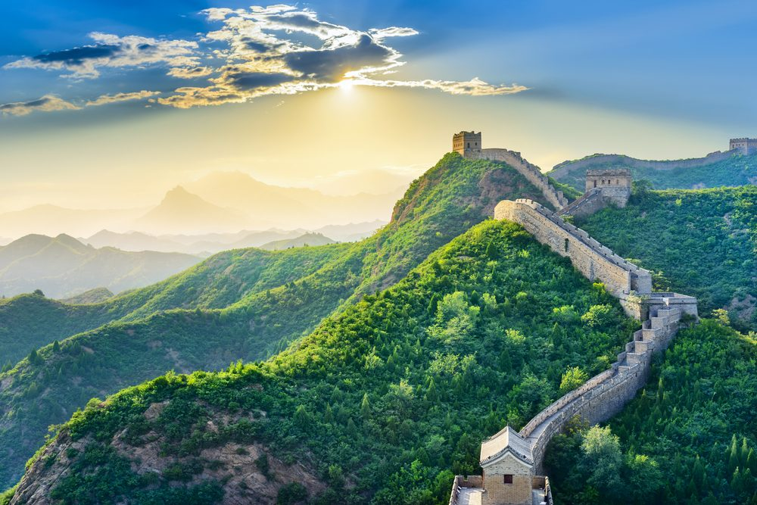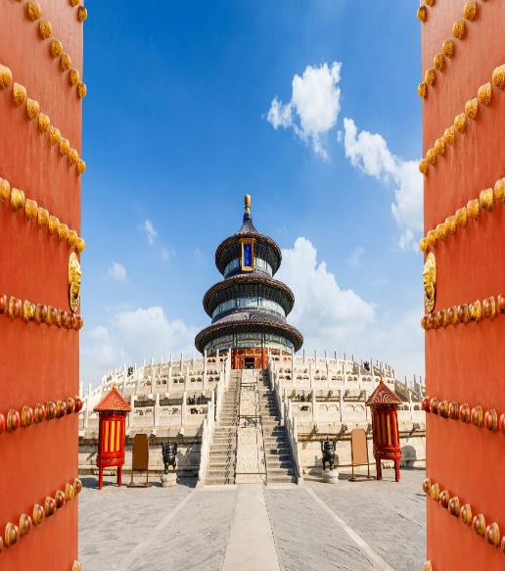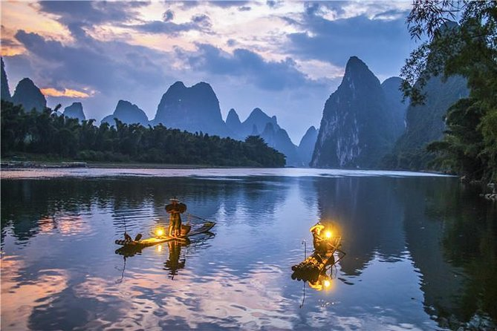
China is home to the oldest of the major world civilizations.
The history of China spans several millennia across a wide geographical area, making it one of the cradles of civilization.
China was ruled by various dynasties for much of its history. The first dynasty is believed to be the Xia dynasty which formed somewhere around 2,250 BC. The Shang or Yin dynasty gained power around the 14th century BC.
China has beautiful scenery, with mountains and ranges, highlands, plains, basins, and hills. The highlands and hill regions account for 65% of the country's total land mass, and there are more than 2,000 lakes. The highest mountain peak is Qomolangma (Everest) in Tibet, the highest in the world, 8,848 meters above sea level; the lowest point is the Turpan Basin, 154 meters below sea level.

Trip Highlight:
- Day 2: Beijing: Temple of Heaven; Tian’an Men Square. The Forbidden City.
- Day 3: Beijing: The Great Wall. Cloisonne Factory. Rickshaw on Hutong.
- Day 4: Beijing - Xian: Beijing Summer Palace. Train to Xian.
- Day 5: Xian: Terra Cotta Warriors. History Museum. Muslim Street. Gao Yue Song Folk House.
- Day 6: Xian - Giulin: Old City Wall. Big Wild Goose Pagoda (Buddhist temple). Flight to Giulin.
- Day 7: Giulin: Li River cruise. Yangshuo Town / Xi Jie Street.
- Day 8: Guilin – Shanghai: Giulin: Elephant Trunk Hill Park. Reed Flute Cave. Flight to Shanghai.
- Day 9: Shanghai: Old Town (Tea House; Mandarin Yu Garden). Jade Buddha Temple. Shanghai Museum.
- Day 10: Shanghai: Zhujiajiao (Water Canals). Taoist Temple. Yuanjin Monastery.

Package will be quoted in USD per person and would include:
- 03-Night accommodation in BEIJING at the hotel category of your choice
- Day 2: breakfast, lunch, dinner.
- 02-Night accommodation in XIAN at the hotel category of your choice
- Breakfast and lunch basis
- High speed train (2nd class ticket) from Beijing to Xian
- Domestic flight from Xian to Giulin on economy class
- 02-Night accommodation in GUILIN at the hotel category of your choice
- Breakfast and Lunch basis
- Domestic flight from Giulin to Shanghai on economy class
- 03-Night accommodation in SHANGHAI at the hotel category of your choice
- Breakfast and Lunch basis. Day 11, return date: breakfast only
- Transfers Airport – Hotel – Airport by private car
- Tours by air-conditioned deluxe coach
- Lake cruising
- Boat fees
- Escorted Tours with local English speaking guides
- ALL Entrance Fees
- Travel insurance covering covid
- Free E-Sim card
- Package excludes air ticket

No. Nights | City | Star | Hotel Name
Superior Class Hotels
3N | Beijing | 4 | SUN WORLD HOTEL BEIJING or similar  http://www.sunworldhotel.com.cn/html/Eng/Index.html
2N | Xi'an | 4 | GRAND NEW WORLD HOTEL XI'AN or similar  www.gdhxian.com
2N | Guilin | 4 | GRAND LINK HOTEL or similar
3N | Shanghai | 4 | HOLIDAY INN DOWNTOWN SHANGHAI or similar
First Class Hotels
3N | Beijing | 5 | RENAISSANCE BEIJING WANGFUJING HOTEL or similar  www.marriott.com.cn/hotels/travel/bjswf-renaissance-beijing-wangfujing-hotel/
2N | Xian | 5 | GRAND MERCURE ON RENMIN SQUARE or similar
2N | Guilin | 5 | SHERATON GUILIN HOTEL or similar  http://www.sheraton.com/guilin
3N | Shanghai | 5 | GRAND CENTRAL HOTEL SHANGHAI or similar  www.grandcentralhotelsh.com
Legend: Breakfast (B); Lunch (L); Dinner (D)

Important Notices:
- We are doing our best endeavors to continuously introduce new packages in new cities for you to explore.
- Fares are On Request basis.
- The Itinerary or program may be subject to change as per suppliers’ latest updates and/or logistic issues.
- Actual rates will be given upon quoting / booking and this according to the recommended / selected route, availability and seasonality.
- In case the mentioned hotel is unavailable, then alternate hotel of similar category will be provided.
- Hence, you can select Your Hotels according to Your Budget. Choose between a budget minded accommodation, standard, first class and luxury hotel alternatives.
- Room types or category may be different and subject to availability.
- Few suggestions on sites to see and activities to enrich your stay.
- The list of packages, program duration (no. of stays) and itineraries are Not exhaustive.
- Other Packages to China are available and/or can be tailor-made. Just email us.
- No copyright infringement of pictures or details are intended.

ITINERARY

Day 1: BEIJING
Arrival in Beijing, meet your guide and transfer to your hotel.

Day 2: BEIJING (B, L, D)
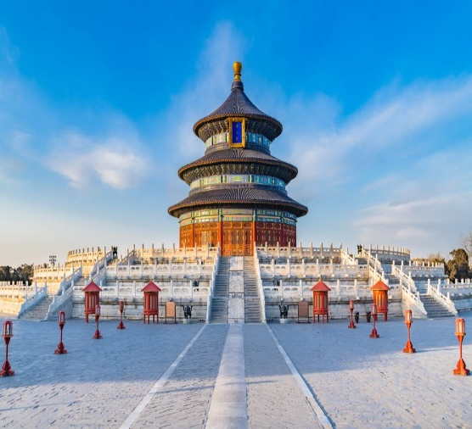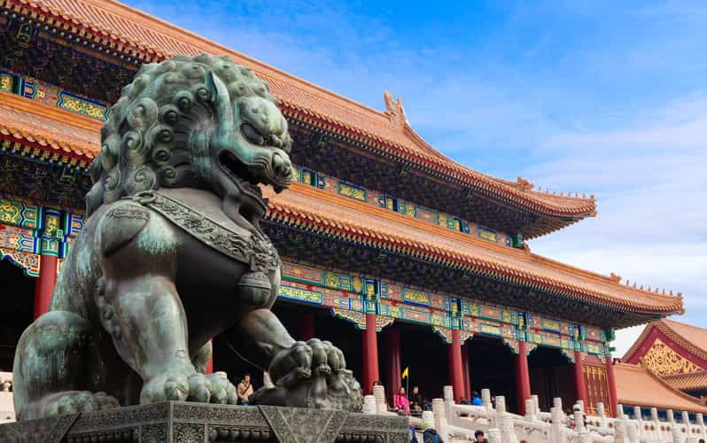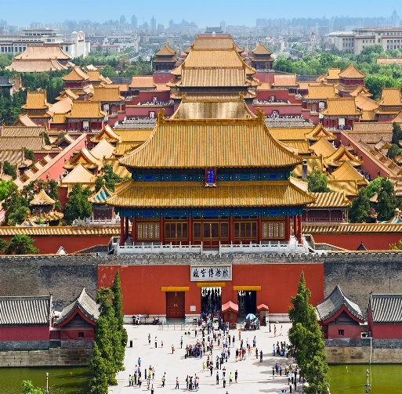
- Breakfast then in the morning, visit the Temple of Heaven to see how locals do their morning exercise.
- Pause in the Temple of Heaven - built in 1,420 A.D. during the Ming Dynasty – as a sacrifice to the Heavens. Chinese emperors called themselves "The Sons of Heaven”, they did Not dare to build their own dwelling” Forbidden City" bigger than the Heaven one.
- Lunch at local Chinese restaurant.
- After lunch, visit the Tian'an Men Square –the heart of Beijing City and admire Tiananmen Tower, Monument to the People's Heroes; and the Forbidden City, known as the Imperial Palace Museum or Gugong, the place where the emperors of the Ming and Qing Dynasties carried out their administration and lived. Currently open to the public where people can witness the bygone architectural era, treasures, and learn the legends and anecdotes of the imperial family and the court.
- Beijing Roast Duck dinner. Overnight at the hotel.

Day 3: BEIJING (B, L)
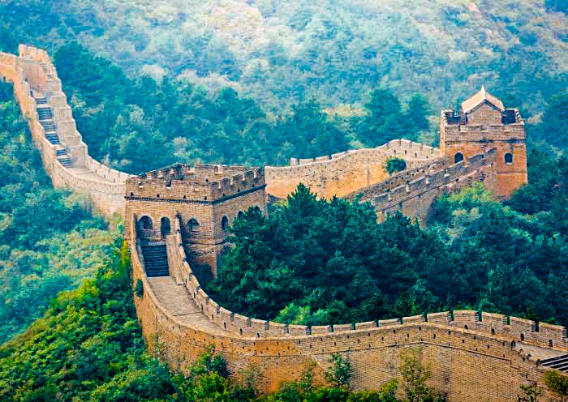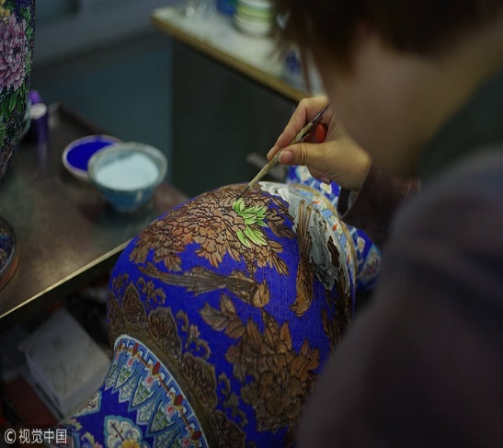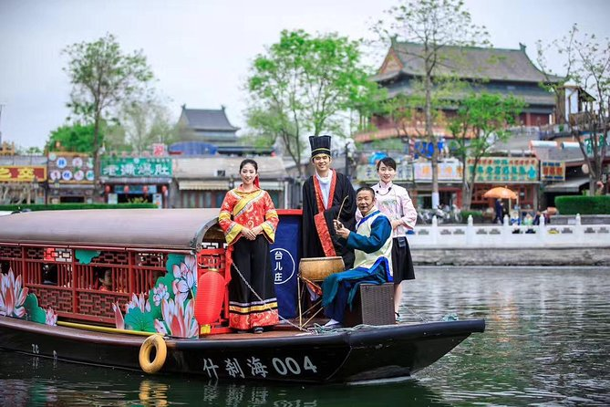
- In the morning transfer to visit the Chinese Great Wall. En route if traffic allows, stop to photograph the iconic “Bird’s Nest” – the Beijing National Stadium – host to many spectacular events of the 2008 Summer Olympics.
- Take an excursion to the Great Wall, Ju Yong Guan Section (there is no cable car). Ju Yong Guan Pass is located in an 18-kilometer long valley named "Guangou" which is inside Changping County more than 50km from Beijing City.
- It is one of the three greatest passes of Great Wall of China. The other two passes are Jiayuguan Pass and Shanhai Pass. It had many different names in the past dynasties. However, the name "Juyongguan Pass" was used by more than three dynasties. It was first used in the Qin Dynasty when Emperor Qinshihuang ordered to build the Great Wall.
- Lunch at local Chinese restaurant.
- After lunch visit a Cloisonné Factory and observe the skilled artisans at work as they create intricate designs.
- In the afternoon, take a rickshaw stroll on Hutong around the Houhai area. The Houhai area can be visited anytime. During the day, enjoy the peaceful lakeside setting, and in the evenings the area transforms into party central – it is a firm fixture on the Beijing nightlife scene; or simply Hire a boat, swim in the lake... You don’t have to wander very far to wind up in one of the Hutongs in the surrounding area. The place offers abundant bars and restaurants.)
- Overnight at the hotel.

Day 4: BEIJING – XIAN (B, L)
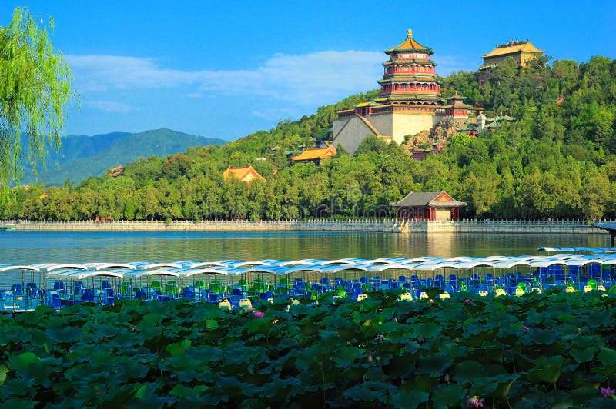
- Breakfast then visit the Summer Palace and Parks – must-see sightseeing in Beijing. Originally it was a retreat used by emperors for 800 years to escape the scorching summer heat of Beijing. The Summer Palace was used by emperors for 800 years till the 18th century.
- In the 19th century, the Empress Dowager Cixi made massive renovations and restored many buildings using money funneled out from the state treasury).
- Lunch at local Chinese restaurant.
- Take the High speed train to Xian (2nd class seat).
- Meet and assist at the railway station and transfer to hotel for an overnight.

Day 5: XIAN (B, L)
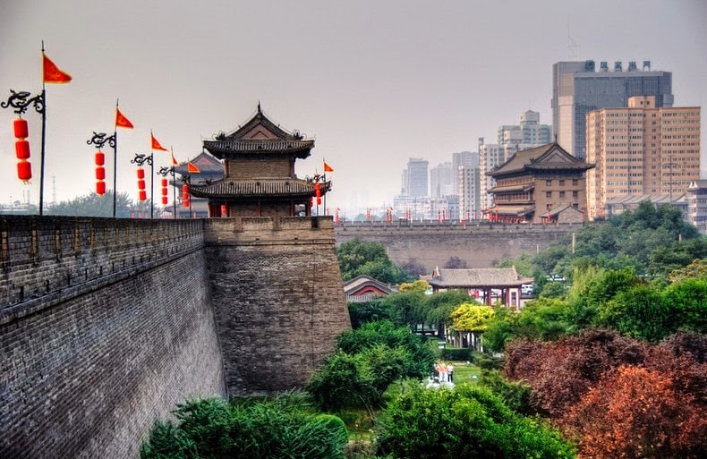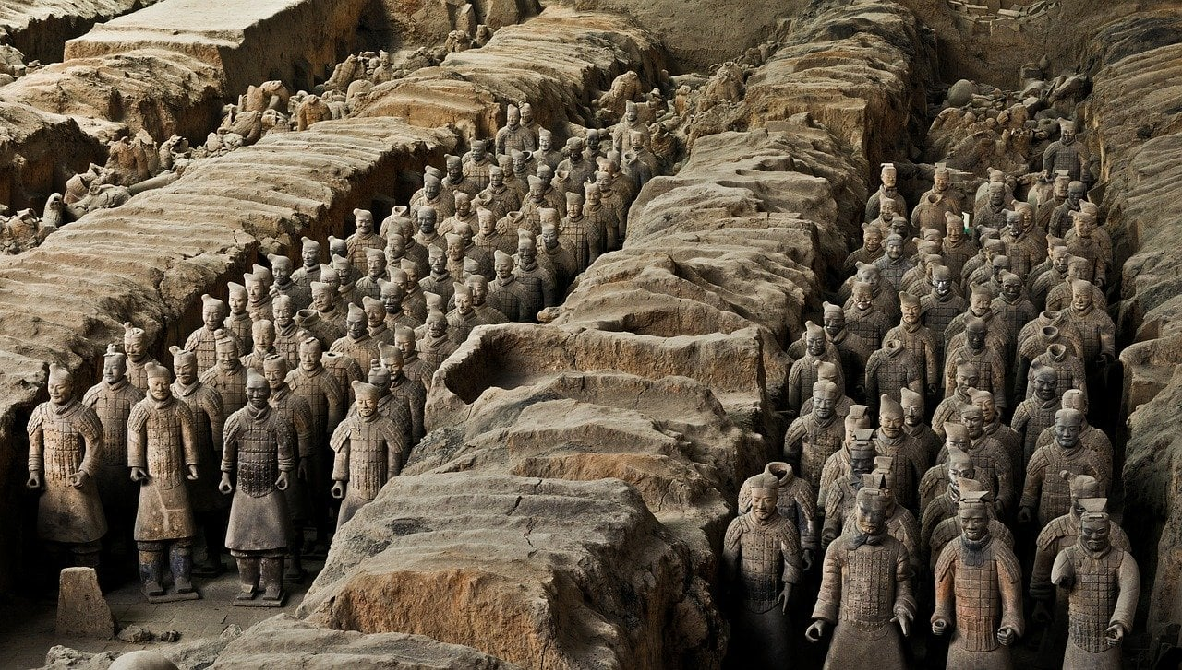
- Breakfast then head to Terra Cotta Army Warriors, the most significant archeological excavations of the 20th century – an Absolute must see. i.e. Life-sized terracotta figures of warriors and horses arranged in battle formations; replicas of what the imperial guard looked like during this era of pomp and vigor.
- On the way back, visit the Provincial History Museum - a striking Tang-Dynasty style pavilion that houses a large collection of 113,000 historic and cultural artifacts unearthed in Shanxi.
- Wander alone along the Muslim Street, 500m long, situated near the Drum Tower; and paved with dark colored stone, green trees and on both sides are buildings modeled on the styles of both the Ming (1368-1644) and the Qing Dynasties (1644-1911).
- Lunch at local Chinese restaurant.
- Continue to GaoYue Song’s ancient-styled Folk House, a high ranked official in Ming Dynasty 300 years ago. This famous house won the “Prize for Cultural Heritage Protection in Asian-Pacific Area of UNESCO in 2002”.
- Enjoy the local Shadow Play Opera there.
- Overnight at the hotel.

Day 6: XIAN – GUILIN (B, L)
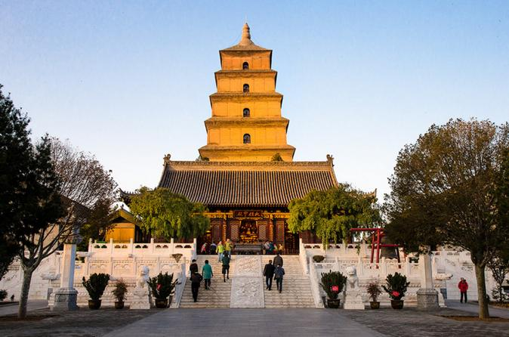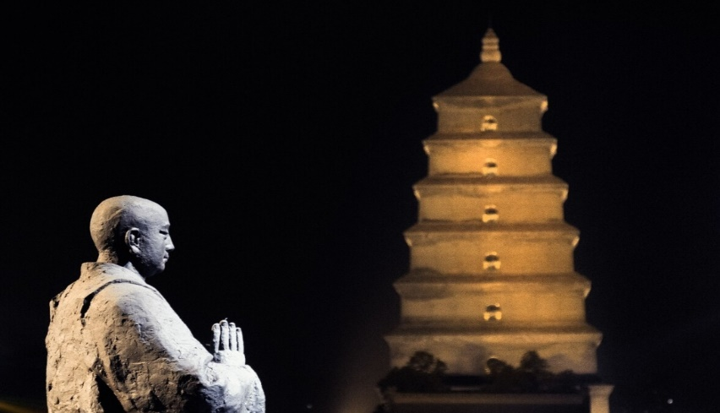
- Breakfast then visit the Old City Wall, a major landmark, the best preserved, the oldest and largest of the city defence systems in China.
- Continue to The Big Wild Goose Pagoda, situated in the Da Ci'en Temple, and known for the best-preserved Buddhist temple complex, four kilometers away from the city center. It is one of the city's most distinctive and outstanding landmarks, possibly the most beautiful building left in Xian today.)
- Lunch at local Chinese restaurant.
- Take an internal flight to Guilin - Flight to be advised. Pick up at airport and transfer to hotel. Overnight at the hotel.
Day 7: GUILIN – YANGSHUO – GUILIN (B, L)
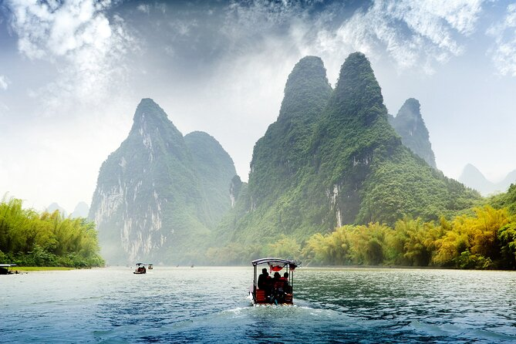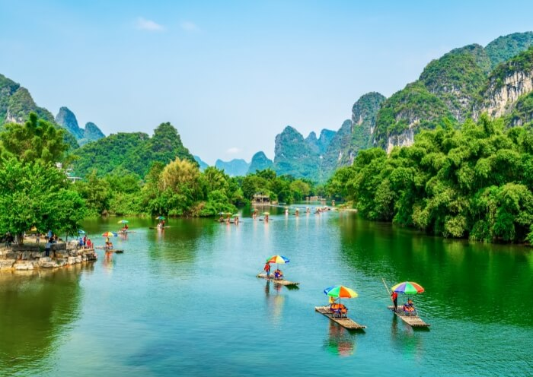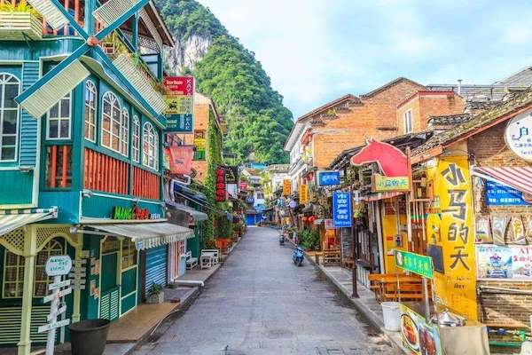
- Breakfast then enjoy a cruise on Li River through amazing landscapes of limestone peaks to the village of Yangshuo. Take time to stroll along its streets, West Street (Xi Jie). Yangshuo, the most beautiful town along the Li River, was built in 590 during the Sui Dynasty with the Li River passing by on the east, the street, which has experienced much wind and rain, is still well preserved, revealing the resplendence of past days. Elegant scenery, superior dining and snacks, pause in Xijie for a coffee.
- Lunch on board.
- Have a short exploration of Yangshuo town before driving back to Guilin.
- Overnight at the hotel.

Day 8: GUILIN – SHANGHAI (B, L)
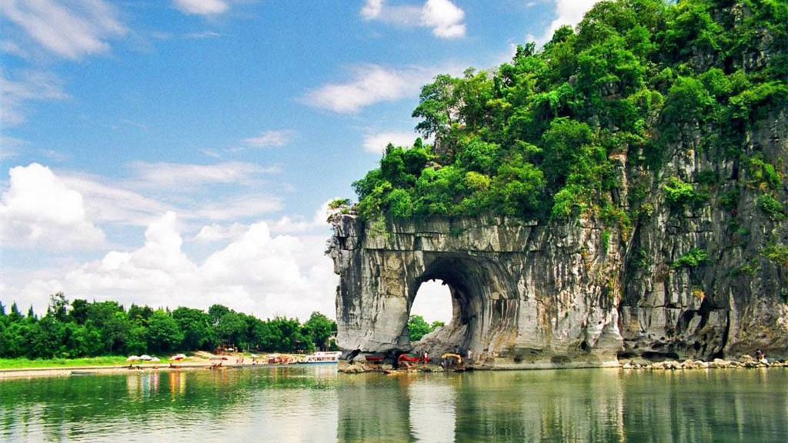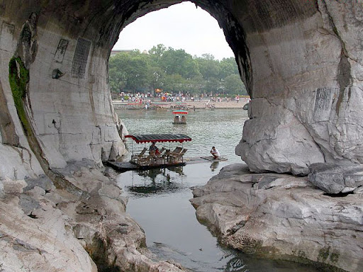
- Breakfast then visit the Elephant Trunk Hill Park, situated at the southeast of Guilin city and west bank of Li River and regarded as the symbol of Guilin landscape. Originally named "Li Hill", "Yi Hill" and "Chenshui Hill", the hill has a history of 3.6 hundred million years.
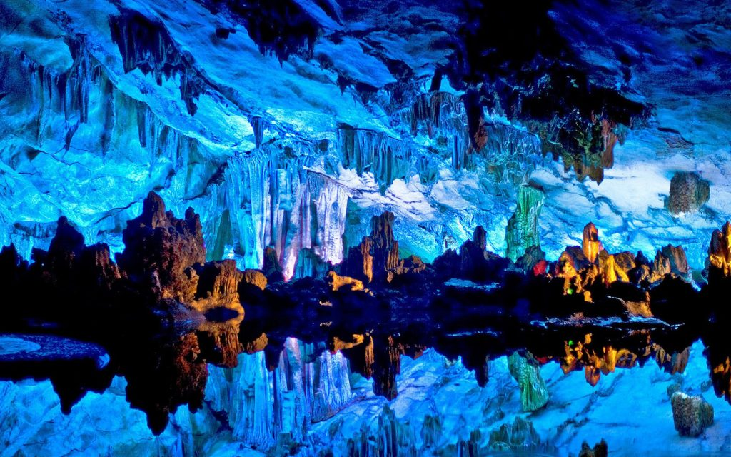
- The “Palace of Nature Art” Reed Flute cave, situated at 7-kilometer from the city center, is a limestone cave dating back to 600,000 years.
- Lunch at local Chinese restaurant.
- Fly to Shanghai, flight number to be advised. Meet, Pick up at airport and transfer to hotel.
- Overnight at the hotel.

Day 9: SHANGHAI (B, L)
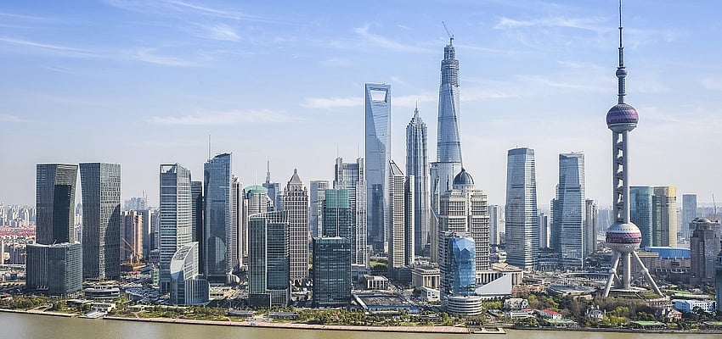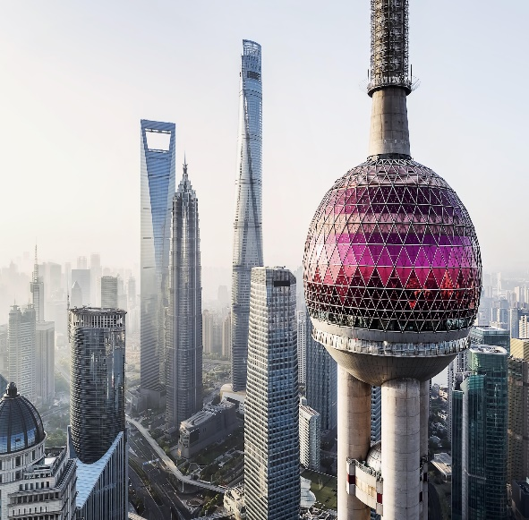
- Breakfast then visit Shanghai’s old town, still known for its bustling atmosphere and lively old lanes.
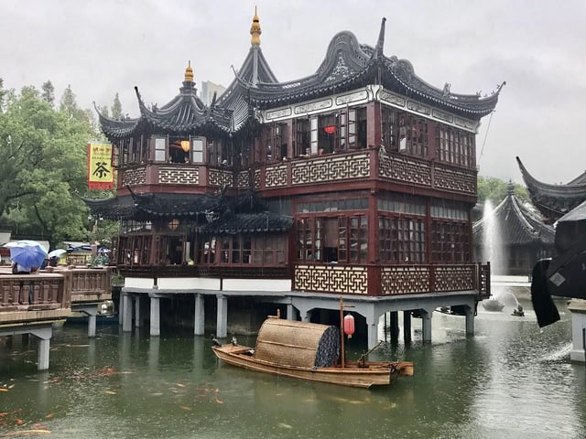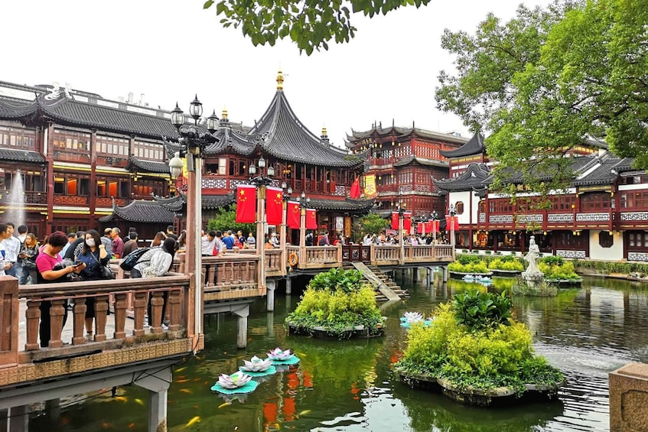
- Visit the Tea House, Mandarin Yu Garden “Yuyuan” a place of peace and comfort in the heart of bustling Shanghai dating back to the fabled Ming Dynasty.
- Yuyuan began as a private garden created by Pan Yunduan, who spent almost 20 years - and all of his savings - to build a garden in order to please his parents in their old age. That is why he called this garden "Yuyuan" - because "yu" in Chinese means "peace and health".
- Lunch at local Chinese restaurant.
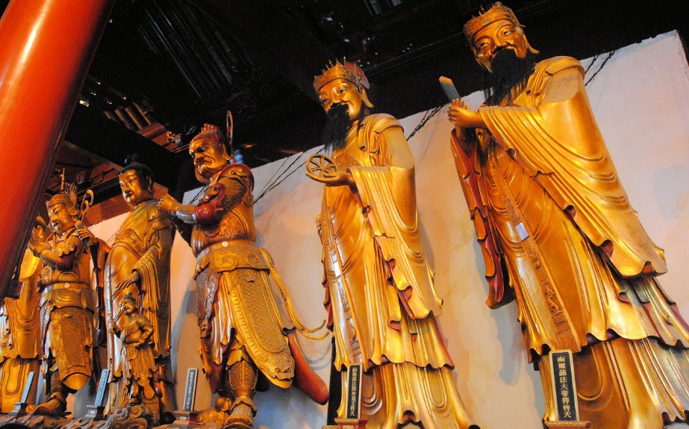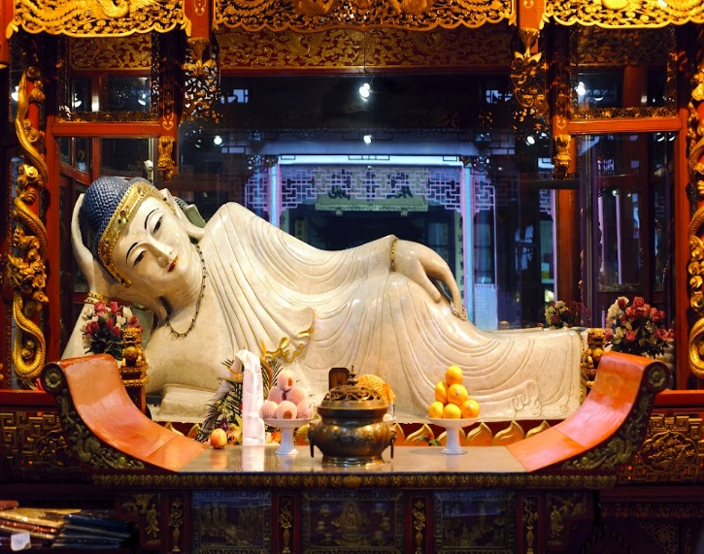
- Admire the Jade Buddha Temple (In the western part of Shanghai, a very modern and flourishing city), a famous Buddhist temple. In 1882, an old temple was built to keep two jade Buddha statues which had been brought from Burma by a monk named Huigen.)
- Visit the Shanghai Museum (without earphone) (The biggest museum in China, with a collection of over 120,000 pieces of Chinese art and cultural relics. The museum is especially famous for its treasures of bronzes, ceramics, paintings, and calligraphy). Attend Shanghai acrobatics show at Portman Hotel (regular seats).
- Overnight at the hotel.

Day 10: SHANGHAI (B, L)
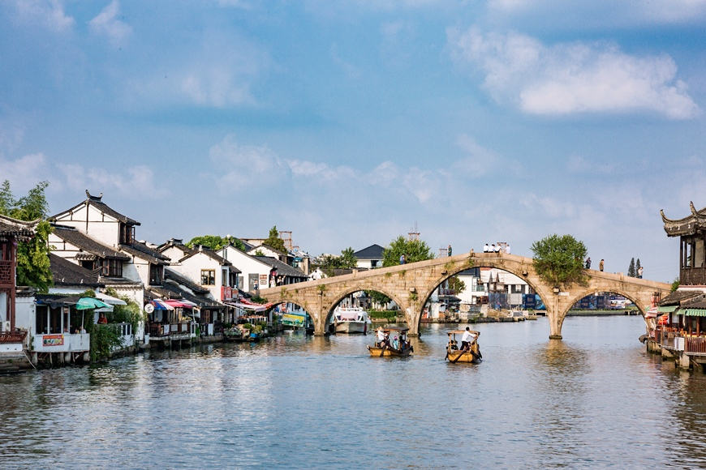
- Breakfast then journey to the traditional water canal town of Zhujiajiao, dating back as far as the Ming and Qing dynasties. Visit a local Taoist temple and the Yuanjin Monastery.
- Wander around in the quaint shops of the winding streets.
- Lunch at local Chinese restaurant.
- Return to Shanghai and free day at leisure.
- Overnight at the hotel.

Day 11: SHANGHAI (B)
Transfer to the airport for departure flight.

